CENWP-OD-B 26 July 2023

MEMORANDUM FOR THE RECORD

SUBJECT: 23BON068 MFR AFF Valve 15 Pacific Lamprey Mortalities

On the morning of 26 July, Columbia River Inter-Tribal Fish Commission (CRITFC) Biologists notified Bonneville Project Biologists of three lamprey mortalities found on the valve 15 trash rack in the Adult Fish Facility (AFF). The fish were scanned for PIT tags, inspected, and returned to the river.

- Species – Pacific Lamprey (Entosphenus tridentatus)
- Origin – Unknown
- Length – In descending order in the picture: 59.1 cm, 58.4 cm, 67.3 cm
- Marks and tags – None
- Marks and Injuries found on carcass – None
- Cause and Time of Death – Unknown
- Future and Preventative Measures – None
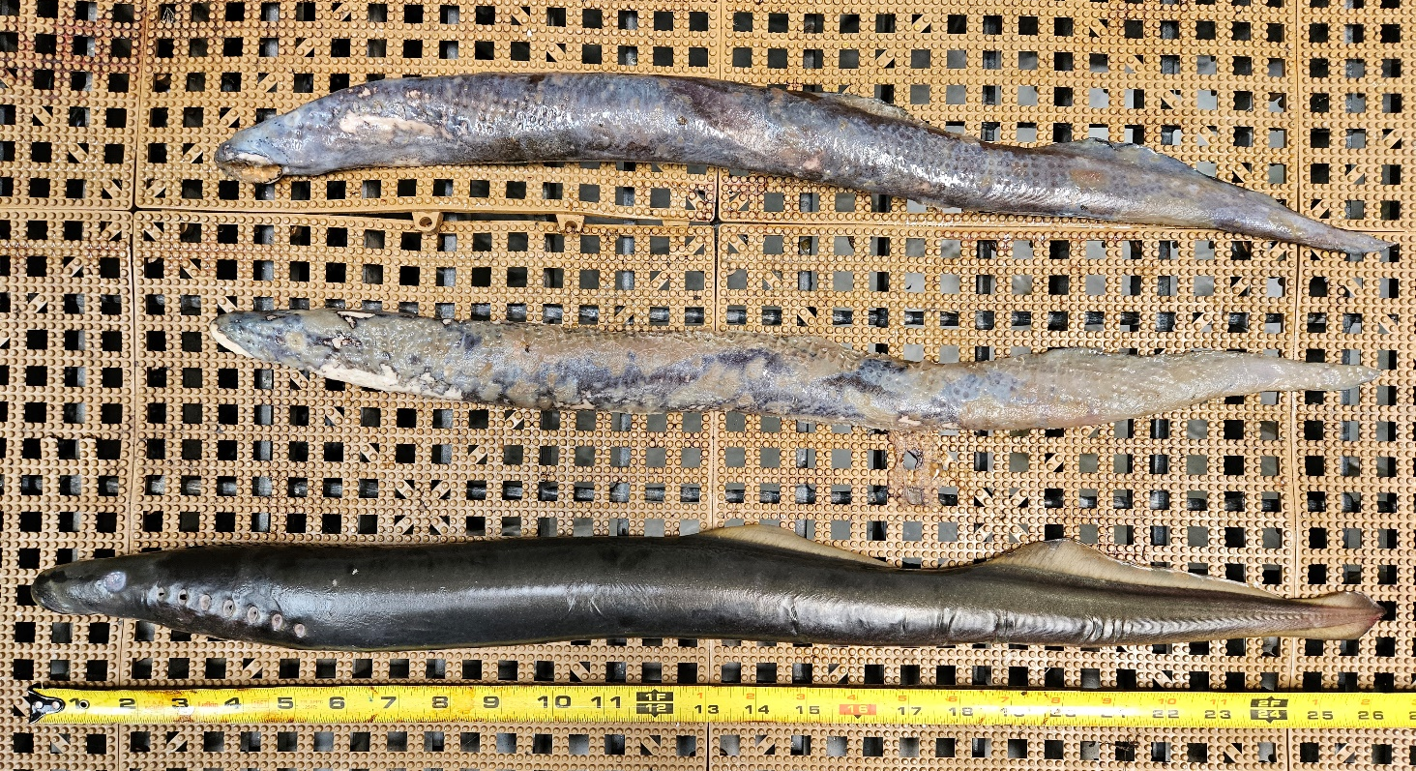

Sincerely,
BON Project Fisheries

